**Challenge 8**

[www.pythonchallenge.com/pc/def/integrity.html](http://www.pythonchallenge.com/pc/def/integrity.html)

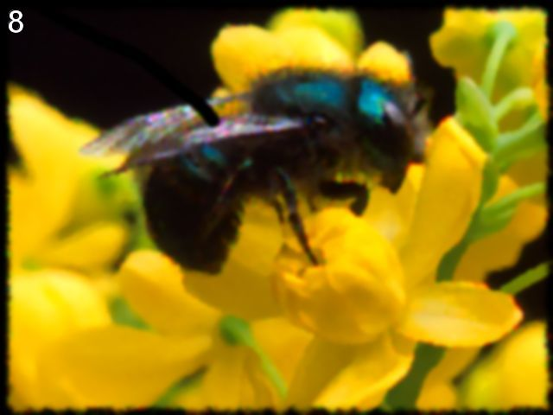

The source has a couple of clues: first is a link to another page:

href="[../return/good.html](http://www.pythonchallenge.com/pc/return/good.html)" which you get to by clicking on the bee.

Then these lines:

|  |
| --- |
| <!-- |
|  | un: 'BZh91AY&SYA\xaf\x82\r\x00\x00\x01\x01\x80\x02\xc0\x02\x00 \x00!\x9ah3M\x07<]\xc9\x14\xe1BA\x06\xbe\x084' |
|  | pw: 'BZh91AY&SY\x94$|\x0e\x00\x00\x00\x81\x00\x03$ \x00!\x9ah3M\x13<]\xc9\x14\xe1BBP\x91\xf08' |
|  | --> |

So we need to get the username / password for the next challenge page.

Since un and pw lines start with BZ, the clue must be in some weird format. In fact, googling ‘python bz’ brings up ‘bz2 – support for bzip2 compression.’ So, the idea must be that the un / pw stuff is in some compressed format that is handle by the python module **bz2.**

After playing around (a lot!), I finally extracted the username and password from the web page. (The easy way is to just cut and paste from the source – but where’s the fun in that? Yes, my solution looks icky, but this was the only sort of nice way that I could get around escape problems and I learned a lot about decode / encode, etc.)

Anyway the authorization is huge / file and this goes to the next challenge.